|  |  |
| --- | --- |
| *Pacific Gas and Electric Company* | |
| Release 9.6.3 Install Guide | |
|  |  |
|  |  |
| Project | ED AM/GIS |
|  |  |
| Prepared by | Subhankar Baidya |
| Date | 7/10/2015 |
| Version | 1.0 |
| Version Type | Draft |

|  |  |  |  |
| --- | --- | --- | --- |
| Revision History | | | |
| Document # | Date | Author | Summary of Changes |
| 1.0 | 07/10/2015 | Subhankar Baidya | Initial Document Creation |

# Introduction

## Purpose

This document is intended to detail the implementation and configuration steps required to implement Release 9.6.3 Installation Guide. This document describes the various configuration aspects required to complete any manual or automatic patch associated with this release. Each section in this document contains the steps required to patch the system in production.

## Terms Used

|  |  |
| --- | --- |
| OOTB | Out of the box. Unmodified from the commercial version. |
| TFS | Team Foundation Server |

## External Documents

Referenced are any external configuration documents or exports. These are documents that contain more detailed information about configuring a system or documents that can be loaded into an application to perform the configuration detailed in this document.

## List of Fixes

Below is the list of change requests detailing all fixes for the data model for this release:

|  |  |
| --- | --- |
| **Item Number** | **Title** |
| 22646 | Master TFS DM9.6.3 |
| 22645 | Create new class model – PGE_QAQC and Assign the class model to all the feature classes in the network |

## Summary of Steps to Complete Patch

These are the high-level steps to complete the installation and configuration of the 9.6.3 Installation patch. Use this table as a guide for completing the installation. Links are provided that can lead either within the document for detailed explanations or to external sites such as Sharepoint.

Contents

1 Introduction 3

1.1 Purpose 3

1.2 Terms Used 3

1.3 External Documents 3

1.4 List of Fixes 3

1.5 Summary of Steps to Complete Patch 3

2 Open a Database Connection in ArcCatalog 5

3 Create new class model – PGE_QAQC and Assign the class model to all the feature classes in the network 6

4 Data Model Version Table 8

5 Known Issues 9

# Open a Database Connection in ArcCatalog

1. Open ArcCatalog.
2. Within the Catalog Tree, expand “Database Connections” and open the active connection for this process. This is the connection that is referenced in the change request associated with this document (EDGIS<DB name in the format X#Y> )

# Create new class model – PGE_QAQC and Assign the class model to all the feature classes in the network

1. Get the exclusive access of EDGIS
2. Right click on the root node and select “Properties…”
3. In the “Domains” tab, select “**PGE ED Object Class Model Name**” and add “**PGE_QAQC**” code and description.

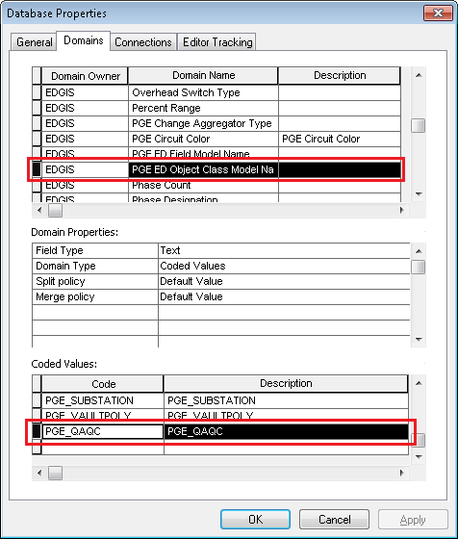

1. Click “Apply”. Click “OK”.
2. Open “SQL Plus” or SQL Developer and connect to EDGIS.
3. Run the following SQL statements:

INSERT INTO sde.mm_class_modelnames (oid, modeldatasetname, objectclassname, subtypeused, subtype, modelname)

SELECT sde.r658.nextval,'EDGIS.ELECTRICDATASET', physicalname, 0, -1, 'PGE_QAQC' FROM sde.gdb_items WHERE objectId IN (SELECT userclassid FROM edgis.n_1_desc GROUP BY userclassid);

commit;

# Data Model Version Table

**Database Configuration:**

1. Open SQL Plus.
2. Log in using the same server and user as was used in section 2.  
     
   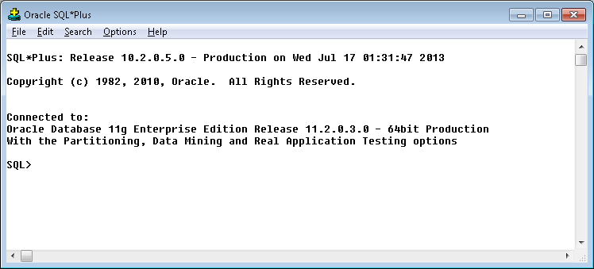
3. Run the SQL below:

update pgedatamodelversion set currentidc='N' where currentidc='Y';

insert into pgedatamodelversion (OBJECTID, CURRENTIDC, DATEAPPLIED, APPLIEDBYPERSONNAME, MODELVERSION) values (**INSERT NEXT VALID ID**,'Y',sysdate,'**<INSERT TEAM MEMBER DONE BY>**','**9.6.3** **TFS Ticket <INSERT TFS#>**');

commit;

# Known Issues

<Please List any other issues encountered here while following the document>